**Dr KALAINGAR GOVERNMENT ATRS COLLEGE**

**KULITHALAI -639120**

**DEPARTMENT OF ELECTRONICS**

**NAAN MUDHALVAN – SMART BRIDEG PROJECT**

**PROJECT TITLE : BUILD A EMPLOYEE TRAVEL**

**APPROVEL APPLICATION**

**SUBMITTED BY**

TEAM LEAD : RAJABABU.V (CB20S274119)

TEAM MEMBER 1 : PRIYA .S (CB20S274117)

TEAM MEMBER 2 :PREMKUMAR.N (CB20S274116)

TEAM MEMBER 3 :PUGAZHENTHI.N (CB20S274118)

**INDEX**

|  |  |  |
| --- | --- | --- |
| **S.NO** | **CONTENT** | **PAGE NO** |
| **1** | **INTRODUCTION** | **3** |
| **2** | **Problem Definition & Design Thinking** | **4** |
| **3** | **Activity & Screenshot** | **7** |
| **4** | **Trailhead Profile Public URL** | **14** |
| **5** | **ADVANTAGES & DISADVANTAGE** | **14** |
| **6** | **APPLICATIONS** | **15** |
| **7** | **CONCLUSION** | **16** |
| **8** | **FUTURE SCOPE** | **16** |

**INTRODUCTION**

Your organization has decided to implement a custom travel approval app. Up until now, you had a travel approval process in place based on emailing spreadsheets. It had no central repository or enforcement of the process, resulting in the inability to report on travel approval activities across the organization. You need to create an application that meets these requirements:

* Each employee must submit an electronic request in the system for future travel.
* Each request includes a list of estimated expenses for airfare, hotel, rental car, and so on.
* Each request must be approved by the employee’s manager, and all out-of-state travel must be approved by a travel coordinator.
* Managers need reports and dashboards to track key travel request trends and KPIs.
* In addition, employees and managers must be able to access their travel requests, approvals, and dashboards via mobile device.

By the end of the project, you’ll have a working prototype of the new travel approval application. You start by creating a travel approval app that provides a view of your specific travel-related objects, which you create in the next steps. Remember that a Salesforce app is a grouping of tabs that give you access to corresponding object data.

**OVER VIEW :**

In this project,

* Build a Lightning app, add tabs, and customize page layouts.
* Create custom objects and fields for the app.
* Define relationships between objects.
* Import data and test the app.

**EMPATHY MAP**

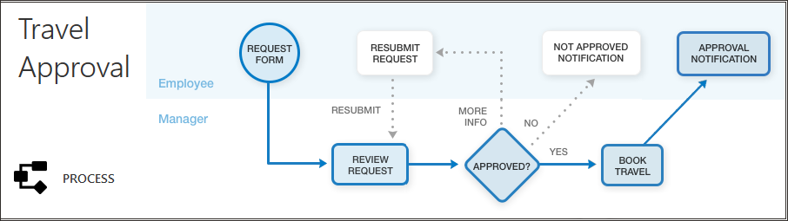

**BRAIN STORMING MAP**

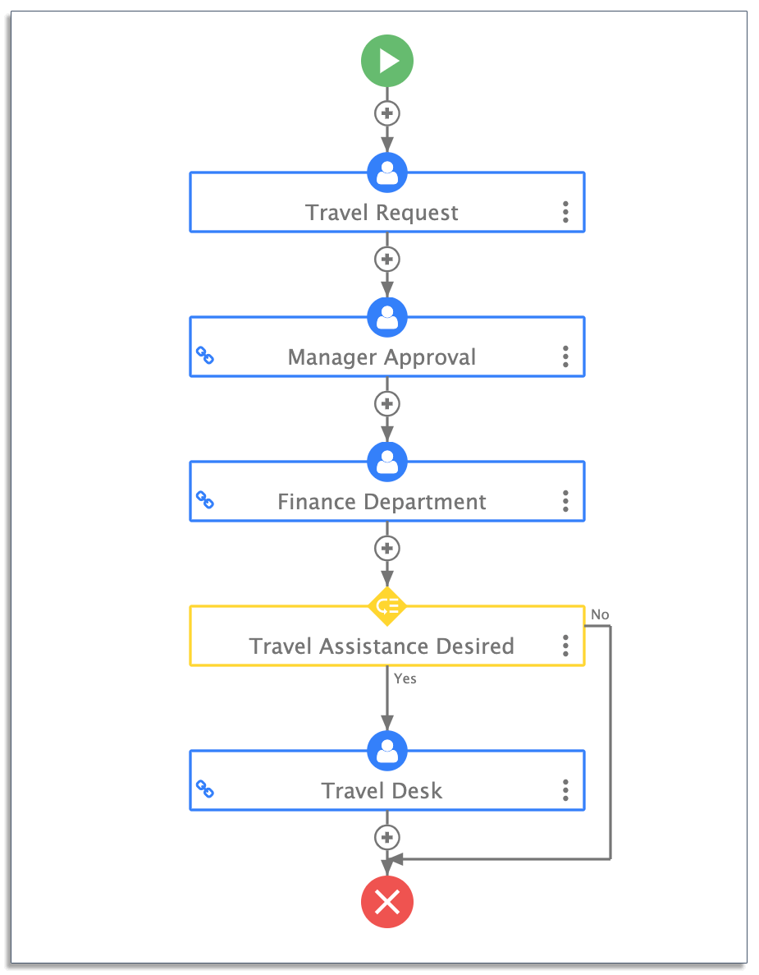

**Milestone 1- Create Salesforce Org:**

Creating Developer Account Creating a developer org in salesforce.

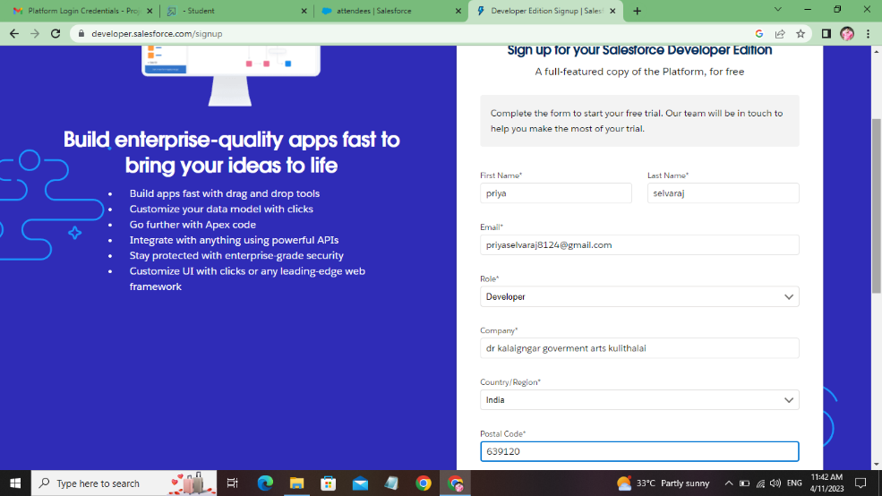

Account Activation.

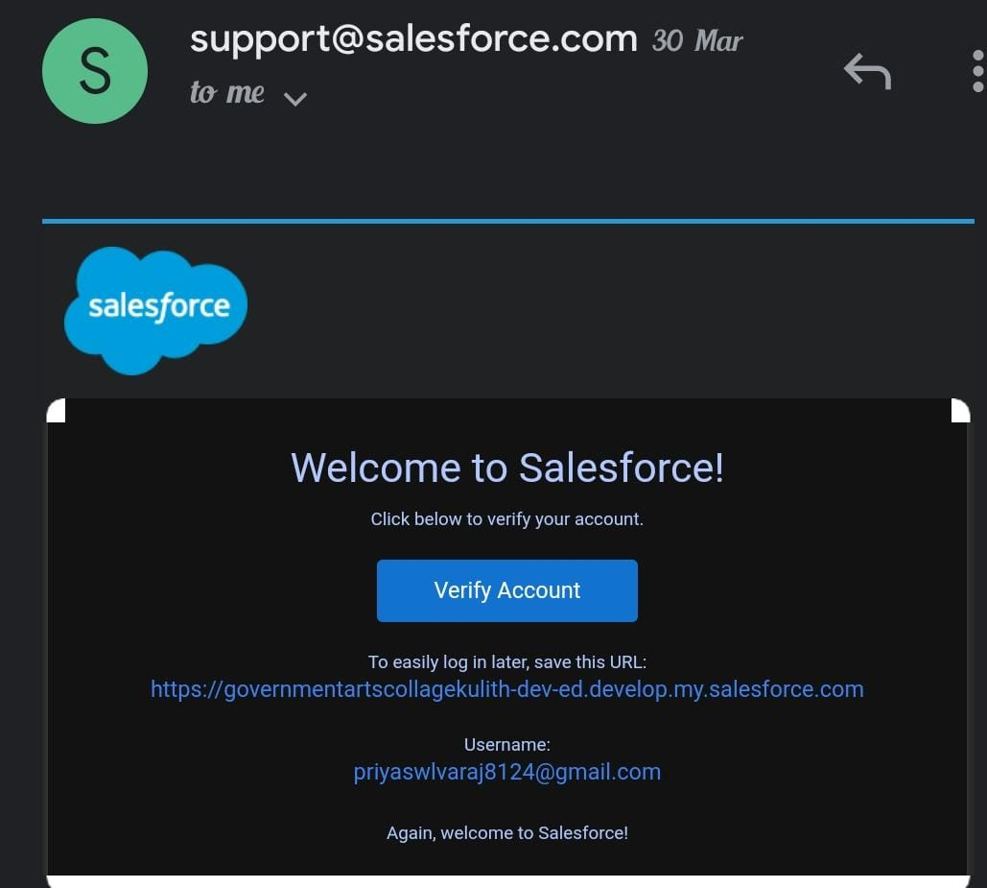

**Milestone 2 Creating the Application:**

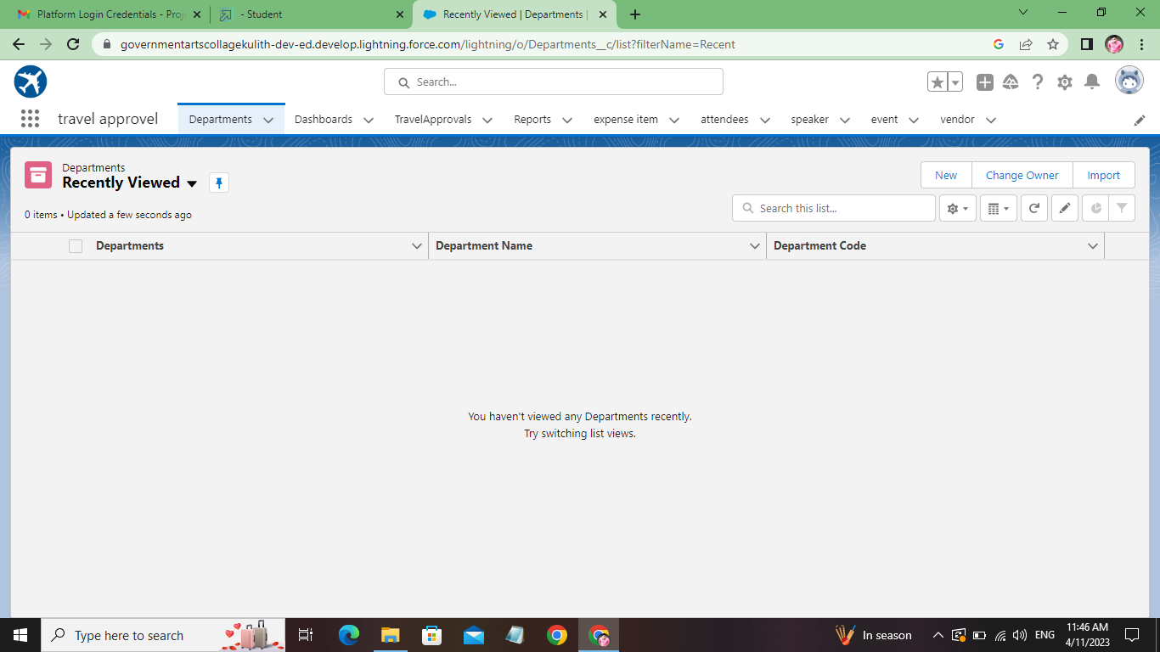

Milestone 3 -:

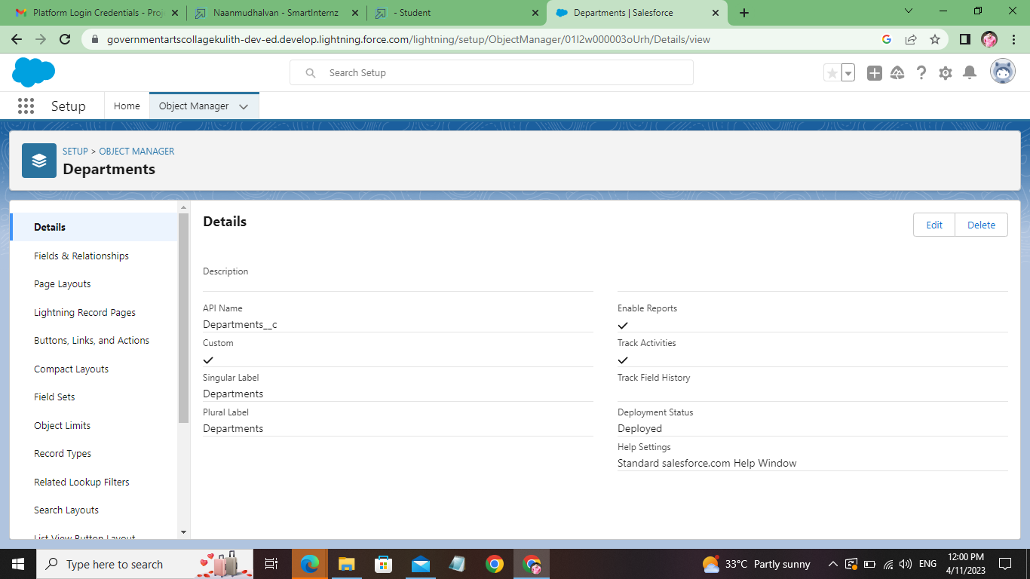

**Milestone 4-What is a Tab?**

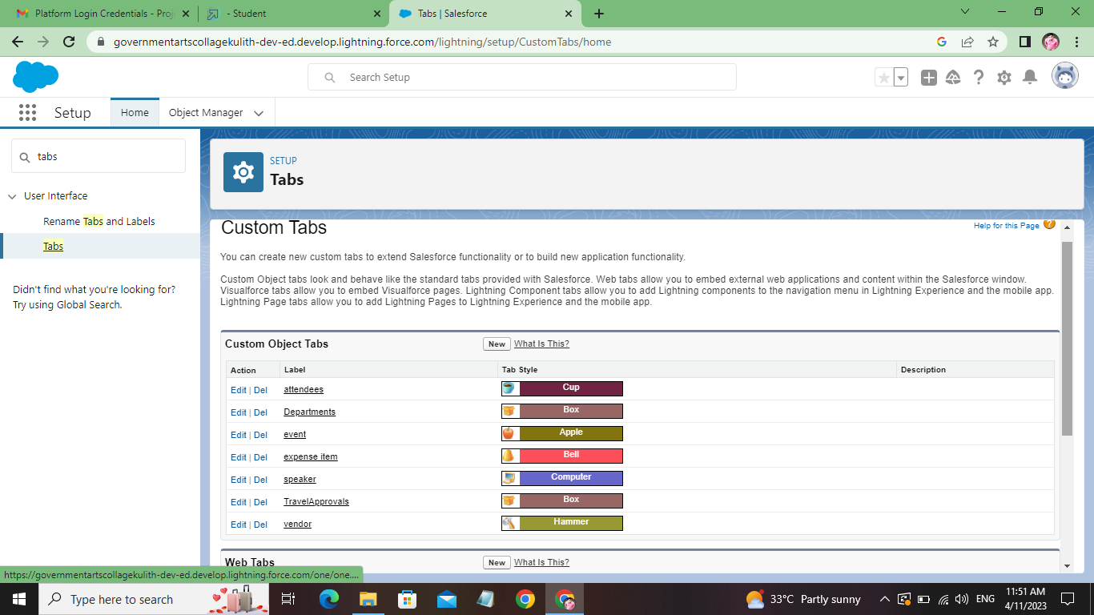

**Milestone 4 Create- Fields& Relationships :** 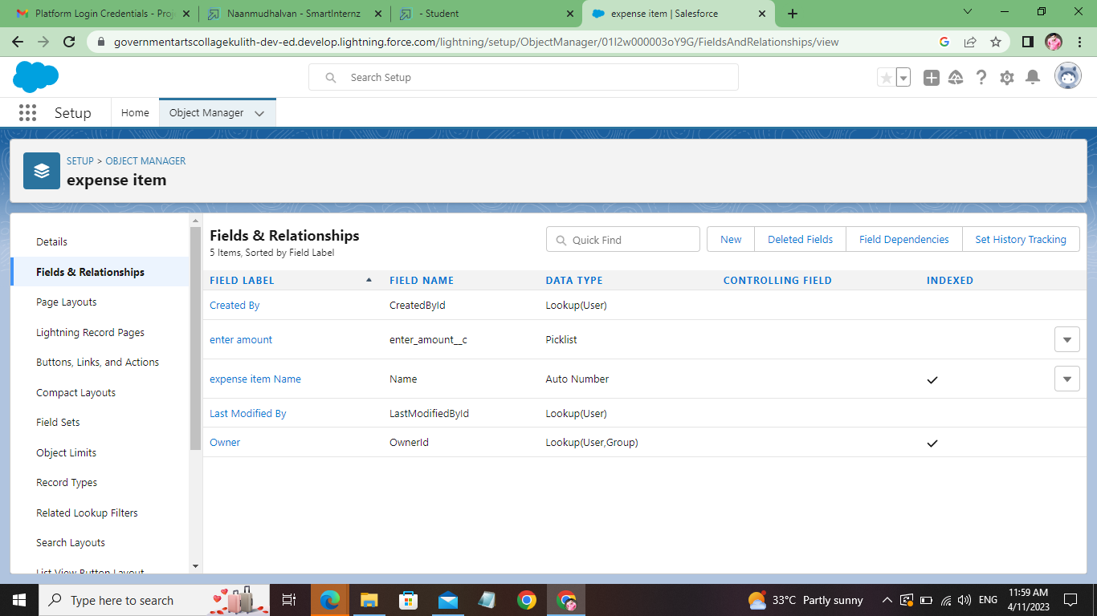 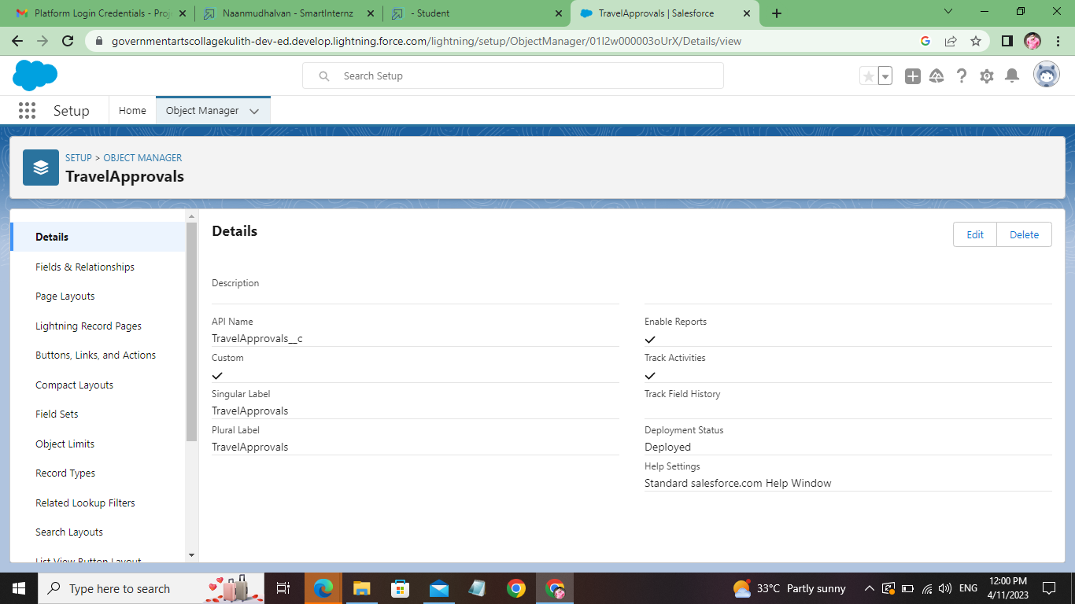

**Milestone 5-Import Departments**

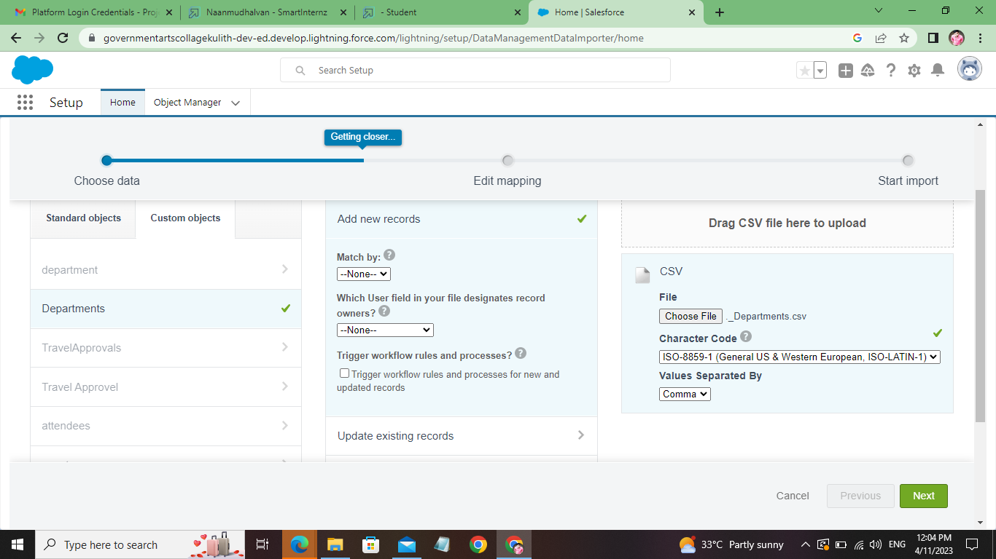

**Milestone 6-Customize User Interface**

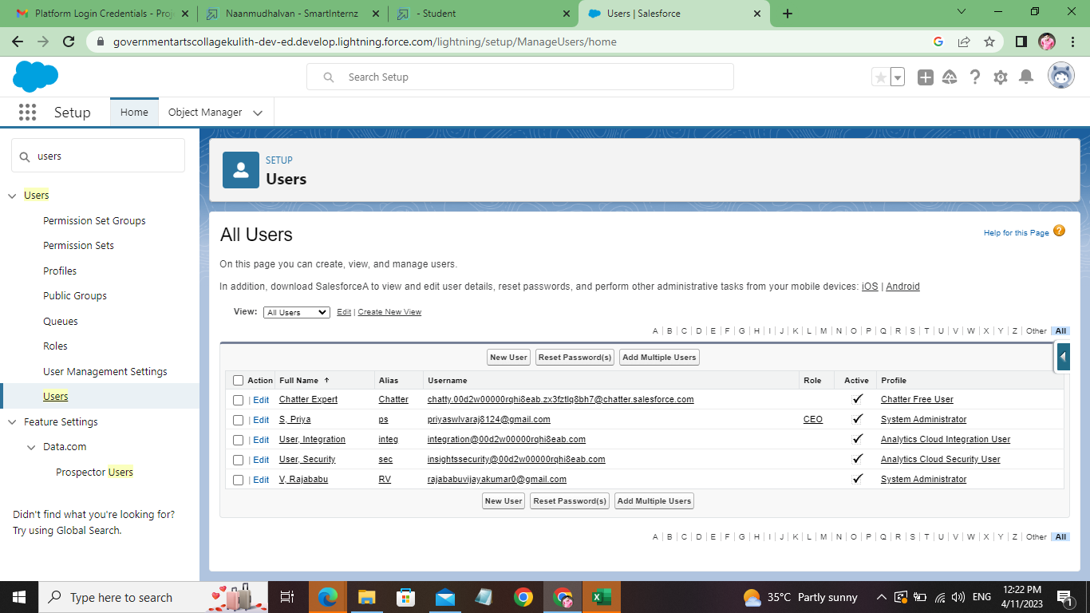

**Milestone 7- Use customization**

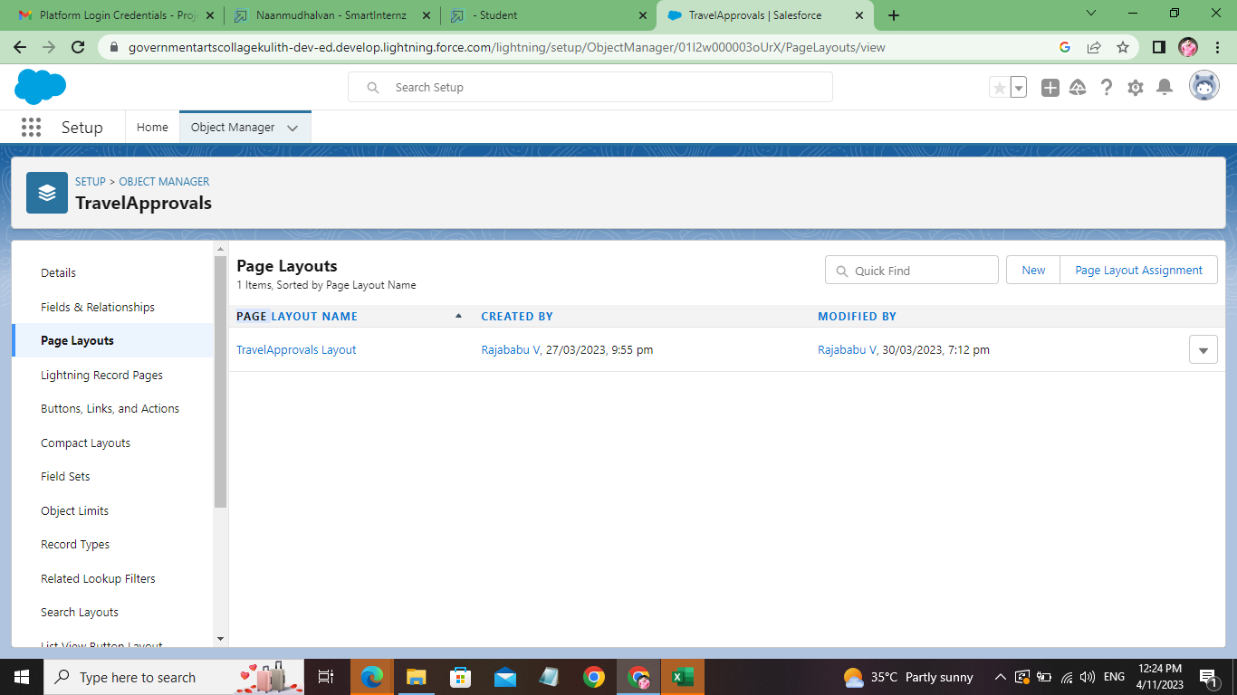

**Milestone 8-Add Business Logic to Travel App**

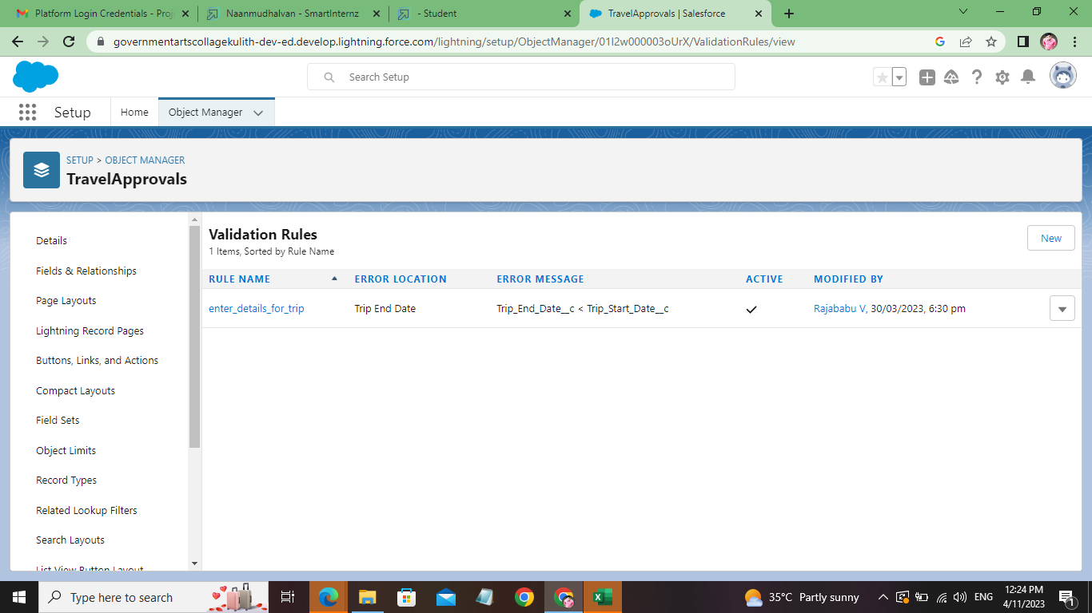

**Milestone 10-What are Reports?**

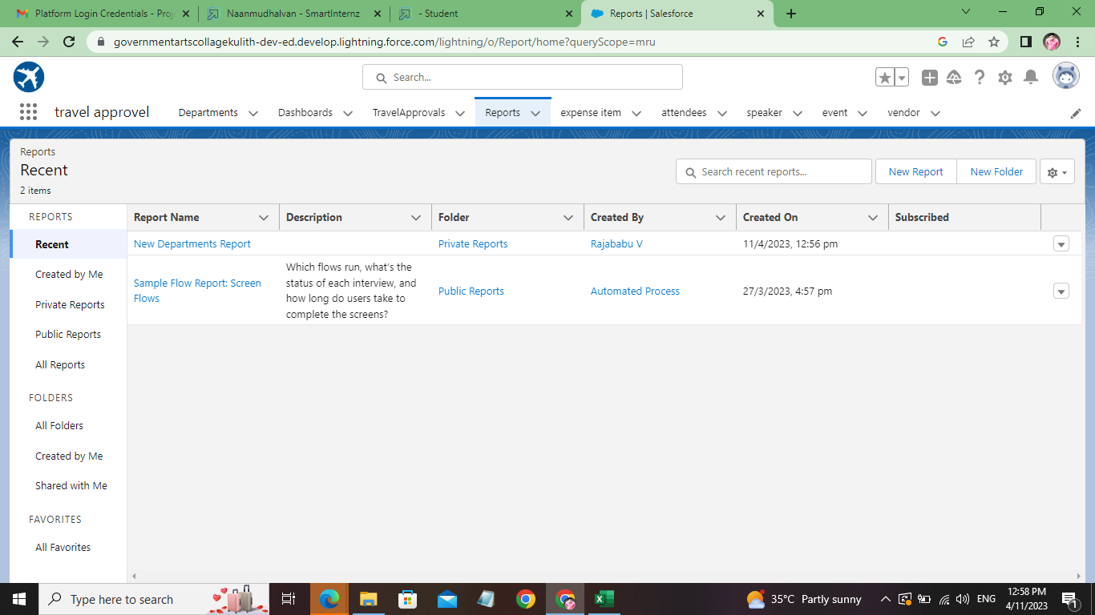

**Milestone 11- Dashboards:**

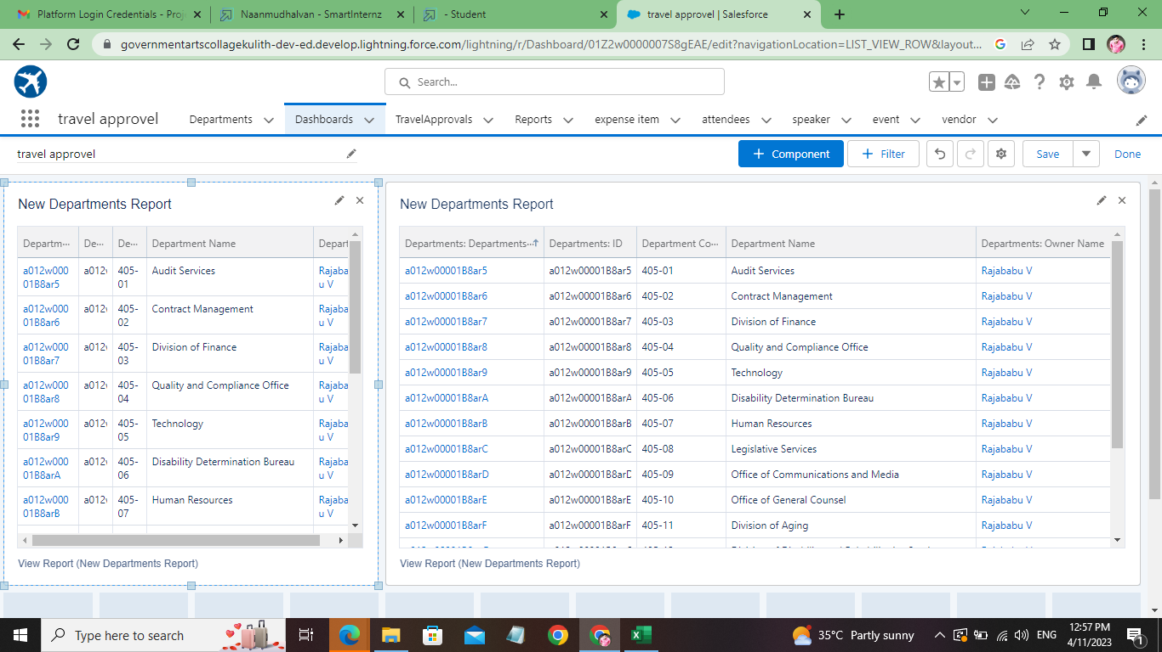

**Trailhead Profile Public URL**

**Team Lead -** **https://trailblazer.me/id/rvijayakumar9**

**Team Member 1 - https://trailblazer.me/id/priys83**

**Team Member 2 - https://trailblazer.me/id/hgahlot3**

**Team Member 3 – https://trailblazer.me/id/pugan**

**ADVANTAGES & DISADVANTAGE**

Advantages Of Traveling

Let’s take a look at the main advantages of traveling the world.

Adventures And New Experiences

Without a doubt, the biggest plus to traveling is all of the new experiences you will get across the world. These are usually experiences you wouldn’t have otherwise like staying with local hill tribes in [Thailand](https://abrokenbackpack.com/category/thailand/) or snorkeling with sharks in [Australia](https://abrokenbackpack.com/category/australia/).

A lot of time while traveling is spent prioritizing having fun and experiencing new adventures, which is so different from our usual daily lives. You can create memories that last a lifetime while traveling, and this is definitely a huge plus when it comes to looking at the advantages of traveling.

Experience New Cultures

You can expand your mind and open yourself up to new cultures and ideologies while traveling. During travel, you are coming into contact with cultures and people that you might not have come into otherwise.

Immersing yourself in the culture of another country can be an opportunity for a lot of learning, and you will see the world through fresh eyes and with a completely new perspective once you get to see how other people live.

Personal Growth

During travel, you spend a lot of time outside of your comfort zone, which leads to a lot of growth at a rapid pace! You will grow to be more independent, even if you are traveling with others.

This can be a great way to gain more confidence too, and learn more about yourself, especially when traveling alone.

Traveling can bring a lot of clarity when it comes to how you want your life to be in the future.

Without the regular stressors of day-to-day life, your mind is clearer to start seeing what is really important to you for your life and your future.

**APPLICATIONS**

The Travel Support System (this is the name that you can see on the screen when executing the application) is a small sample application for NaturalONE. As a sample application, its focus is to show NaturalONE functionality rather than being a full-fledged travel support application.

The Travel Support System (TSS) allows you to request and approve business trips. Flights, hotels and even more external information such as cell phone expenses or car rentals can be entered with the trip request. For the destination, weather information can be queried. A manager can do both, request own trips as well as approve trips that have been requested by employees. After the manager has approved single or multiplerequests, the manager can print an itinerary or receive the itinerary as a PDF file.

The usage of the travel approval application is described below.

**CONCLUSION**

The project aim is to provide real-time knowledge for all the students who have basic knowledge of Salesforce and Looking for a real-time project. This project will also help to those professionals who are in cross-technology and wanted to switch to Salesforce with the help of this project they will gain knowledge and can include into their resume as well.

**FUTURE SCOPE**

The Travel and Tourism Industry has grown by leaps and bounds and it will surely reach even better heights in the times to come. Today, when we talk about the growth of this industry, we cannot ignore mentioning the ample amount of career opportunities that lay subsumed in it.

Keeping up with the changing trends of the industry is vital for making a career in this field. The institutes imparting education in this sector ensure to do that. All the [**Best Hotel Management Colleges in India**](https://www.cgc.edu.in/best-hotel-management-colleges-in-chandigarh-punjab-north-india/) have made provisions to make students industry-ready via different online and offline programs.

Now, it is known to all that the year 2020 has been a little tough for almost every sector and Travel & Tourism is not an exception. But thankfully, with the relaxation provided by the state/country government and the possibility of vaccines to be ready sometime soon shortly, this industry also seems to be coming back on track. The latest mends to the travel and tourism industry have opened more job openings for the aspirants.

A report by [**Business Wire**](https://www.businesswire.com/news/home/20201213005006/en/Travel-Services-Market-to-Grow-by-56-Billion-in-India-During-2020-2024-Domestic-Flight-Services-Segment-to-Present-Significant-Opportunities-Technavio)shares that in the phase 2020-2024, the Travel Services Market is projected to grow by $56Billion in India. This implies that the years to come hold a lot of career scope for those who have completed the studies, currently pursuing and those who are planning on getting themselves enrolled.

To throw light on what this industry brings to the table, we have made a list of different job options it offers